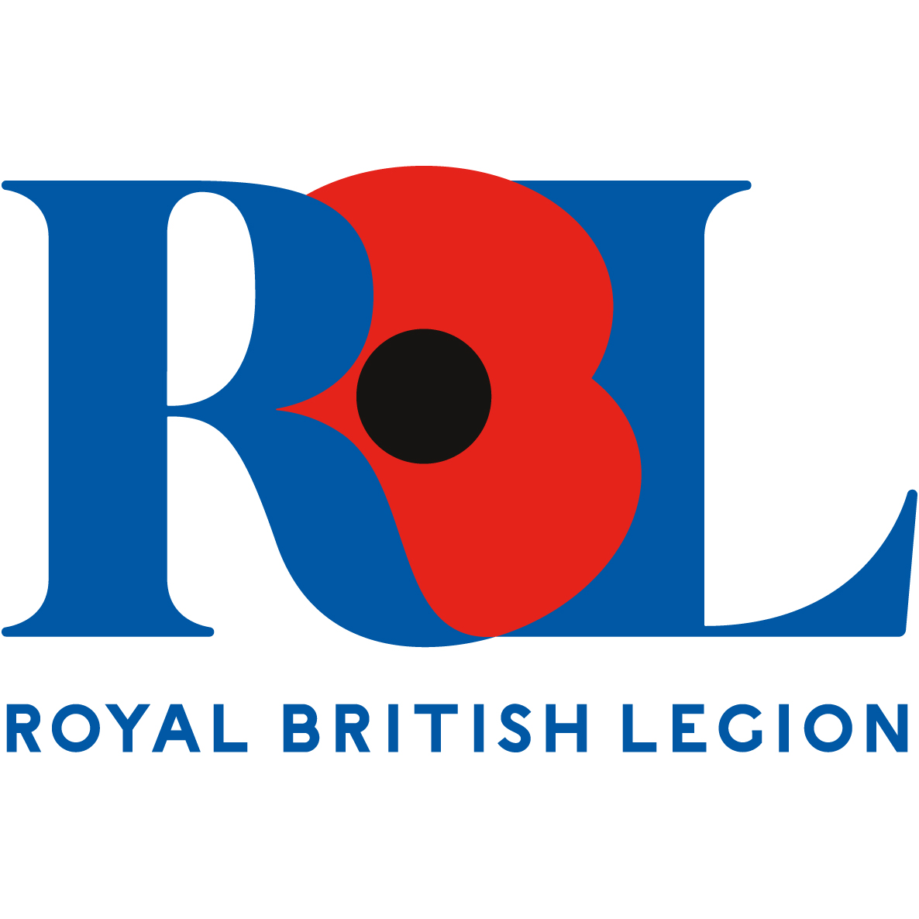
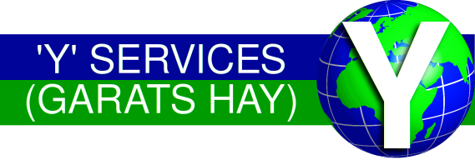
Y Services
Branch

President: Col (Ret’d) E Sambell OBE
Chairman: Dr J McDermott
Vice Chairman: Mr D Weir MBE
Secretary: Mr J Swann
Treasurer: Mrs L Oldfield
AGENDA FOR THE ROYAL BRITISH LEGION “Y” SERVICES BRANCH ANNUAL GENERAL MEETING TO BE HELD AT THE GREENFIELDS SPORTS & SOCIAL CLUB, HOLT DRIVE, LOUGHBOROUGH LE11 3HZ, ON SATURDAY 13TH NOVEMBER 2021, COMMENCING AT 1400 HOURS

- The Exhortation Chairman
- To Close the Agenda Chairman
- Branch Community Support Presentation Matt Ford
- Chairman’s Welcome and Opening Remarks Chairman
- Apologies for Absence Secretary
- Minutes of the 2020 Branch AGM Secretary
- Matters Arising not on the Agenda Secretary
- President’s Address President
- Chairman’s Report and Objectives for 2022 Chairman
- Reports
  - Secretary John Swann
  - Membership Secretary Pete Derrick
  - Branch Community Support Rep Karen Brutnell
  - National Branches District Rep Jim McDermott
  - Y Services Memorial, NMA Jim McDermott
  - Poppy Appeal Organiser Dennis Weir
  - Standard Bearers Dave Lawrence
  - Webmaster Dave Rice
- Presentation of the Branch Accounts Treasurer
- NMA Annual Maintenance Funding 2021/22 Chairman/Treasurer
- Branch Subscription and Joining Fee Chairman
- Branch Elections Chairman/Secretary
- National Branches District Vice Chair Election Secretary
- Appointment of National Branches District Annual Chairman
Conference Delegates
- Appointment of Annual Conference Delegates Chairman
- Nomination for Trustee Elections 2022 Vice Chairman
- Nomination for National Chairman 2022 Chairman
- Summer Gathering 2022 Chairman/Secretary
- Closing Remarks and Date and Place of next AGM Chairman

